In July 2010, I was about to embark on my first caving expedition, at the end of a year’s caving in the UK. It’s easy to say that I was a little excited.

I have always been an adventurous person, I adore the outdoors and I have a great interest in the Earth and thus joining ICCC in October was the inevitable outcome! I had never been caving before, and from the initial presentations and meetings, I was extremely keen to get below-ground. Soon enough, I was hooked and was looking forward to heading off on a 4 week expedition to the Julian Alps in Slovenia.

Slovenia was one of the hardest and most rewarding experiences I have had. After packing up a month’s worth of supplies and cramming as much of it into the minibus as possible, our group of intrepid cavers set off towards Slovenia, a journey taking us through six countries over twenty four hours.

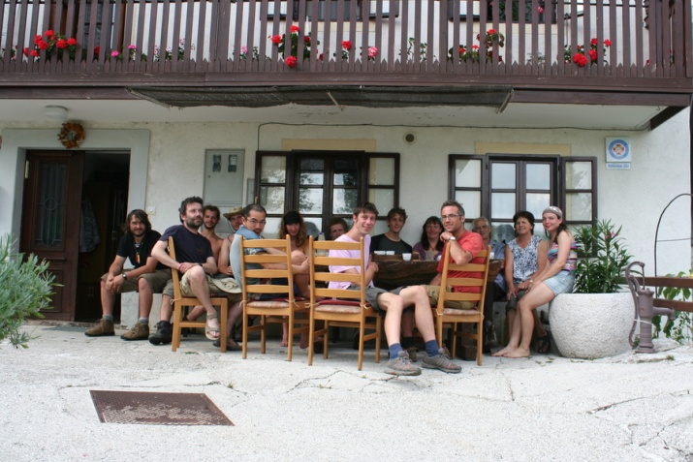Arriving in Slovenia I was immediately taken aback by the country’s beauty, and after spending a night eating pizza and sleeping in Tolmin, we began are ascent of Migovec. The mountain plateau where our base camp was set up is at an altitude between 1800m and 2000m. Driving to a farm at Raune, we shared coffee, packed any remaining space in our bags with food, and headed up Migovec. The first trip to the top was accompanied by a rain cloud, which left us wet, but nicely cool up to the top. The next few days were taken up by cavers making trips up and down the mountain, ferrying equipment, food and most importantly huge volumes of very heavy cheese!

After being showed around the plateau, introduced to the various cave entrances and schooled on the history of the caving on the mountain Nikolas Kral and I prepared for our first sortie underground, with experienced caver James “Tetley” Hooper. Our first trip was in the Vrtnarija section of the cave system of Migovec. Descending through the entrance dubbed Gardener’s World, the three of us made a steady descent to the bottom of the Pico pitch, at about -200m. This was already deeper than either of us had been in our nine month caving experience in the UK! The following day, infested by the caving bug, Tetley and I again entered Vrtnarija, this time descending to the top of Fistful of Tolars pitch, at -400m. These trips also doubled up as opportunities to take some of the gear needed to set up camp at   
-550m. Several other caving trips were made, taking the nine tackle bags down to the middle of Friendship Gallery. These included Kate Smith, another fresher, on her first expedition with Nick and I.

Relaxing at Raune

The cave system within Migovec is genuinely breath taking. Whilst not the most decorated of caves (which we later discover not to be true), the shear nature of the cave is beautiful. Descending through large chambers, with pitches up to 120m, is an exhilarating experience, learning to slide through those tricky parts of the cave and strolling through the large phreatic passages is incredibly liberating.

Soon enough, I was ready to head to Camp X-Ray, our underground camp at -550m. Our underground camp consisted of a 4 man tent inner-lining, which helped to raise the temperature of 1°C by a couple of degrees. We had two Vango Nitestar sleeping bags, which are brilliant, and a set of two buffalo bags, which enabled our camp to become a four man camp. We used methylated spirits and gas stoves to cook with, and had several candles for ambience! As well as a first aid kit, we had a small set of speakers, a small video system and an mp3 full of Blackadder. At -550m, all this made underground camp a very welcome place 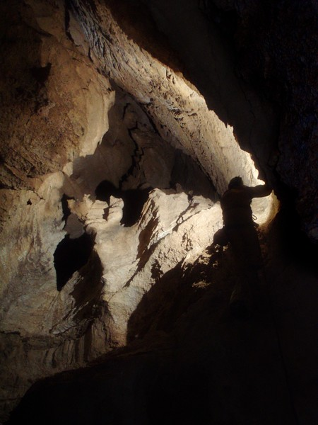indeed.

On my first trip to underground camp Tetley and I spent one night there, pushing the Tolminski Korita series for several hours, and discovering the pitch later named Black Knight. We were joined by Dan Leinad and Andy Jurd after our stay at underground camp, who informed us they’d been pushing a messy pitch named Leopard, which had burst into a decorative horizontal passage which had many leads. We were all excited. On the surface, I helped input our survey data into the computer, and reviewed the new passage we had discovered.

Jana Carga on Black Knight pitch. Photo by Jarvist Moore Frost.

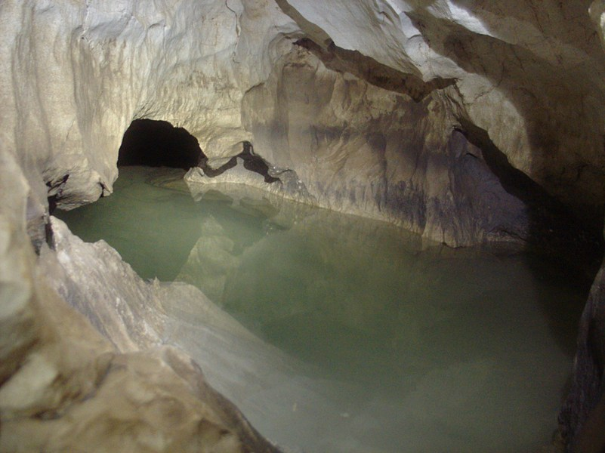Over the next week or so, several caving parties went below, mainly pushing the Leopard series. Tetley and I returned to push Black Knight, which entered further pitches, and then hit a duck. Here I was worried the passage was blocked by the water, however, Tetley cunningly discovered a bypass passage which passed over and around the duck. Jana Čarga and Jarvist Moore frost pushed the series and closed on part, Sidewinder, as it dropped into a part of the cave known as Envy, at about -660m. On my last pushing trip towards the end of expedition, Jarvist and I closed the final part of the Black Knight series, named Stalemate, where the passage grew into a narrow rift too small for us to squeeze through despite our attempts.

Black Knight Duck. Photo taken by Jarvist Moore Frost

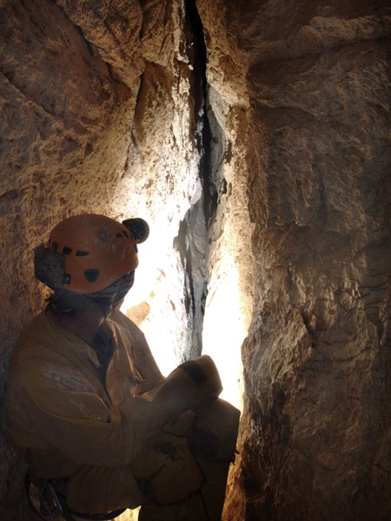Overall, my Slovenian expedition was life changing. 2.2km of undiscovered cave was found, between about twenty cavers, and the depth of the cave was increased. Personally I discovered around 310m of passage with my partners. More importantly, my caving skills improved hugely, I went from taking 3 hours to get to -550m to 1 hour 45 minutes, I learnt how to install bolts, how to tie many knots, and where to use them. My techniques for both abseiling and prussiking improved greatly, and overall I became more confident and proficient in all aspects of caving. I don’t think twice about hauling several tackle bags down a cave anymore! The funding from Alex Pitcher helped me to purchase a Petzl helmet and Mig light attachment, which I used on every underground trip.

Myself looking down Stalemate. Photo taken by Jarvist Moore Frost